AP Biology Review Packet 7: Integration of Information and Ecology
2.A.1: All living systems require constant input of free energy.
environment.
2.D.1: All biological systems from cells and organisms to populations, communities and ecosystems are
affected by complex biotic and abiotic interactions involving exchange of matter and free energy.
3-D2- Cells communicate with each other through direct contact with other cells or from a distance via chemical signaling.
3-E2- Animals have nervous systems that detect external and internal signals, transmit and integrate information, and produce responses
4.A.5: Communities are composed of populations of organisms that interact in complex ways.
4.A.6: Interactions among living systems and with their environment result in the movement of matter and
energy.
4.B.3: Interactions between and within populations influence patterns of species distribution and
abundance.
4.B.4: Distribution of local and global ecosystems changes over time.
4.C.3: The level of variation in a population affects population dynamics.
4.C.4: The diversity of species within an ecosystem may influence the stability of the ecosystem.

- Integration of Informaton
- Endocrine system/Hormones
- Used for slow communication in body (long lasting)
- Chemical messengers
- hypothalamus- makes releasing hormones, ADH and oxytocin and controls pituitary
- Posterior pituitary= holds ADH and oxytocin to be released
- Anterior pituitary= makes GH, thyroid stimulating hormone, FSH, LH, Adrenocorticotropic Hormone and prolactin
- GATOR pit FLAP
- Tropic hormones-stimulate other glands , ex. TSH
- Pancreas= insulin (takes up glucose) vs. glucagon (releases glucose)
- Thyroid = Calcitonin (lowers calcium) vs. PTH (made in parathyroid and increases calcium levels by releasing from storage)
- Gonads= testosterone, progesterone, estrogen
- Adrenal Glands: Stress hormones= mineral corticoids from cortex for long term stress vs. epinephrine from medulla for short term stress (fight or flight)

- Nervous system
- Used for rapid communication
- Brain has grey matter on outside and with matter on inside; cerebrum (thought, senses, etc), cerebellum (balance), brain stem (breathing, heart rate), hypothalamus (sex drive, hunger, thirst, temperature); medulla oblongata (part of brain stem- breathing); pons (part of brain stem)
- Neuron
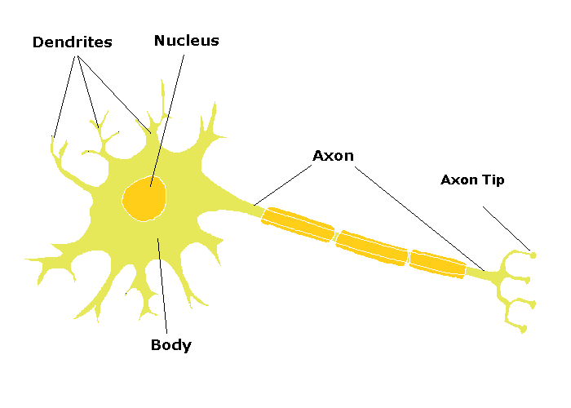
- Myelinated nerves allow for rapid impulses; salutatory conduction
- Action potential (resting, depolarization- less negative because sodium flows in, repolarization- more negative because potassium flows out; hyperpolarization)
- Sodium/potassium pump (restores difference)
- “All or none law”
- Neurotransmitters- ex. Acetylcholine, bring impulse from one neuron to another through synapse; enzymes used to break down neurotransmitter; ex. Acetylcholinesterase

- Ecology

ECOLOGY- interactions of organisms with physical environment and each other
- Organization
Biosphere- all places on earth that contain living things

Biome- regions that exhibit similar characteristics

Ecosystem - living organisms and environment

Community- group of populations in the same area

Population- groups of the same species in an area

- Populations
- same species, same time, same place
- carrying capacity- # of organisms that can be supported
- limiting factors; density dependent- food, space, predators; density independent- severe environmental disturbances
- K-selected Populations: Strategy is to produce few offspring with higher cost (energy); Tend to stay close to carrying capacity; Ex. Mammals
- R-selected Populations: Boom and Bust organisms (opportunistic); Strategy is to produce a lot of offspring with no parental care; Ex. Insects

- Community
- all populations in an area
- interspecific interactions
- competition; competitive exclusion; niche partitioning
- predator/prey relationships (predators pop. size increases as prey pop. size increases but lags)
- symbiosis: commensalism- +0, mutualism- ++, parasitism- +-
- keystone species are species that control population size of other species or are a needed part of food web

- Ecosystem- biotic and abiotic components
- one way flow of energy from sun -> autotrophs -> heterotrophs
- cycling of mineral elements (P, N) and inorganics (CO₂, H₂O)
- sun- ultimate energy source for ecosystem
- trophic feeding levels
- primary producers- convert sun’s energy into chemical energy of glucose
- primary consumers- herbivores
- secondary consumers- carnivores that eat herbivores
- tertiary consumers- top of the food chain; eat secondary consumers
- detritivores/decomposers- eat dead things
- 10% transfer to each level, 90% is used for metabolism/lost as heat

- Biogeochemical Cycles
- water cycle- water cycles between land and air; goes to air by evaporation and transpiration; goes to land by condensation and precipitation
- carbon cycle- carbon cycles between air, organisms, and land; carbon dioxide in air taken up by plants, plants eaten by consumers; organisms give carbon off to air by respiration and by decomposition (soil to air)
- phosphorus cycle- phosphorus is trapped in minerals in rocks and is released into water/soil by weathering (rain, snow, etc.)
- nitrogen cycle- nitrogen cycles between air, organisms and soil; nitrogen in air is fixed by soil bacteria via nitrogen fixation; plants use nitrates; organisms eat plants; bacteria return gaseous nitrogen via denitrification and decomposition

- Biosphere- the part of the earth with living organisms
*biomes- groups of organisms in common climate and with distinct vegetation
- temperate deciduous forests- us; good soil; seasonal
- taiga- coniferous forests; ex. Colorado
- tundra- Arctic; little or no rainfall; short summers
- grasslands- good for agriculture; little or no tall vegetation
- deserts- very little rainfall; cold or hot
- tropical rain forest- most biodiverse but worst soil; uniform temp and a lot of rain

- Ecological succession- replacement of one community by another
a. primary succession- bare rock->lichens->moss->soil->grass->shrubs->pine ->hardwooods
b. secondary succession (result of natural disaster)- grass->shrubs-> pines->hardwoods

- Population Ecology
- Density- numbers of individual per unit area; dispersion patterns = clumped, uniform or random
- Measurement methods
- quadrant sampling- count individuals in a sample plot
- mark and recapture- # marked first day x total caught next time
# captured on second day with mark

- Demographics- composition of population
    - Sex
    - Birth rate (fecundity) vs. death rate (mortality)
    - birth rate= # of births/total pop x 100
    - Death rate = # of deaths/total pop x 100
    - Growth rate (r) = births- deaths/total population;If r > 0, the population is growing, if r < 0, the population is declining, if r = 0, zero population growth (ZPG)
    - Doubling time= 70/growth rate (kept as a percetange, i.e. 10% = 10) or .7/r (keep r in decimal form)
    - dN (change in population)/dt (change in time)= B-D

- Models of Population Growth
- Survivorship Curves
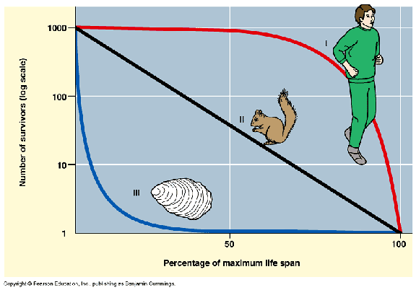
I= high adult mortaility
II- uniform mortality
III- high infant mortality

- Exponential Growth
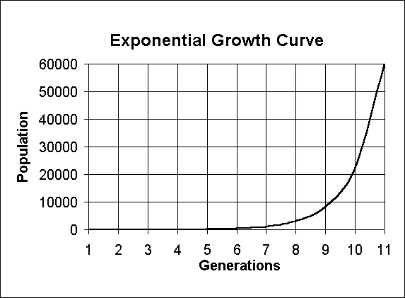
- Called a J curve
- No limiting factors or carrying capacity
- Constant growth rate; larger population adds more indviduals in next generation
- dN/dt= r_{max} N

- Logistic Curve
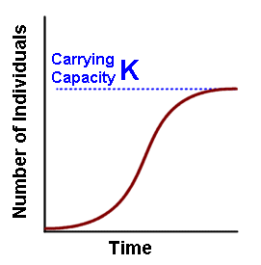
- Called an S curve
- Modified by limiting factors
- Carrying capacity is where it levels off and can hold no more individuals; it is dynamic (changes generation to generation) but static carrying capacity is used in calculations dN/dt= r_{max}N (K-N/K)
- Age structure curves- broad base = growing population; uniform = zero or slow growth, broad top= negative growth

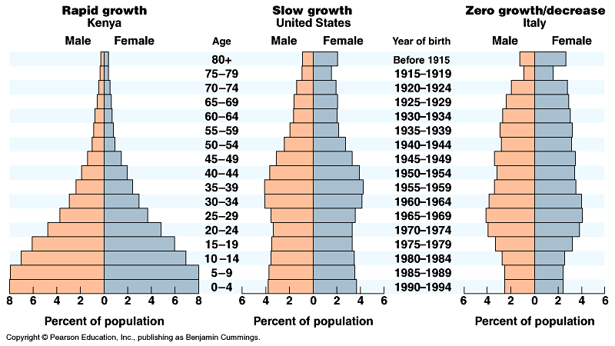

- Disruptions
- Deforestation (disrupts carbon cycle)
- Acid rain (disrupts water cycle)
- Global warming (disrupts carbon cycle- TOO much greenhouse effect from excess carbon dioxide in atmosphere)
- Ozone depletion (damaging sun rays are not filtered) due to CFC’s and destruction of 0₃
--------------------------------------------------------------------------------------------------------------------------------------------------
AP Biology Investigation 10- Energy Dynamics (simulated)

Overview Part I: Net primary productivity of Fast Plants- Data was given on fast plants that were grown over 14 days. Dry mass was divided by wet mass to obtain biomass. Bio mass was multiplied by 4.35 kcal to obtain net primary productivity per 10 plants and divided by 10 to get NPP per day per plant.
IV- Time
DV- NPP

Overview Part II: Energy flow between plants and butterfly larvae (caterpillars)- brussel sprouts and caterpillars were massed before and after 3 days of caterpillar consumption. Biomass (dry/wet) and energy constant were used to calculate how much energy from plant was used in cell respiration and how much was lost as water. PLANT ENERGY CONSUMED PER INDVIDUAL (plant change in biomass )- ENERGY PRODUCTION PER INDIVDUAL (larvae change in biomass) – FRASS ENERGY (energy lost in poo)= RESPIRATION ESTIMATE

IV- time
DV- change in energy (calculated by biomass)

AP Biology- Dissolved Oxygen Lab (old AP manual)- simulated
Overview: Bottles with algae were placed in varying amounts of light (screens used) to determine change in productivity. One bottle was placed in the dark and one bottle was measured before light was administered (initial bottle).

Equations: NPP= GPP- Respiration; NPP= Initial Bottle – Light Bottle; Respiration= Initial Bottle- Dark Bottle

IV= number of screens
DPP= NPP

endocrine signaling
diabetes
endocrine signaling
insulin
glucagon
hormone
saltatory conduction
Schwann cells
sensory neuron
sensory receptor
serotonin
abiotic factor
abundance
adaptation
age structure
biodiversity
biome
biotic factor
carbon cycle
carrying capacity
climate change
community
conservation
decomposer
demography
density dependent factor
food chain
food web
global warming
greenhouse effect
greenhouse gas
gross primary productivity
habitat
hydrologic cycle
imprinting
interspecific competition
intraspecific competition
introduced species
K-selection
keystone species
learning
nitrogen cycle
nutrient cycle
parasite
photoautotroph
population
population growth
population size
pollution
predator
primary consumer
quadrat
rate of increase
resillience
r selection
saprophyte
detritovore
distribution
ecologial niche
ecological pyramid
ecological succession
ecosystem
ecosystem stability
endangered species
exponential growth
life history
life tables
limiting factor
logistic growth
mark and recapture
migration
mortality
mutualism
net primary productivity
secondary consumer
species diversity
survivorship curve
symbiosis
ten percent rule
threatened species
trophic efficiency
trophic level
urbanization

--------------------------------------------------------------------------------------------------------------------------------------------------
Questions and Practice

- Discuss how humans maintain stable sugar levels in their blood stream.
- Discuss how humans respond to stress.
- Discuss how nerve impulses travel in the human body (include- receptions, action potential, active transport, neurotransmitters, etc.)

- What models are useful in describing the growth of a population?
- How is a population size regulated by abiotic and biotic factors?
- How is energy flow through an ecosystem related to trophic levels?
- How do elements cycle through ecosystems?
- How do organisms affect the cycling of element and water through the biosphere?
- How do biotic and abiotic factors affect community structure and ecosystem function?
- In which ways are humans affecting biogeochemical cycles?

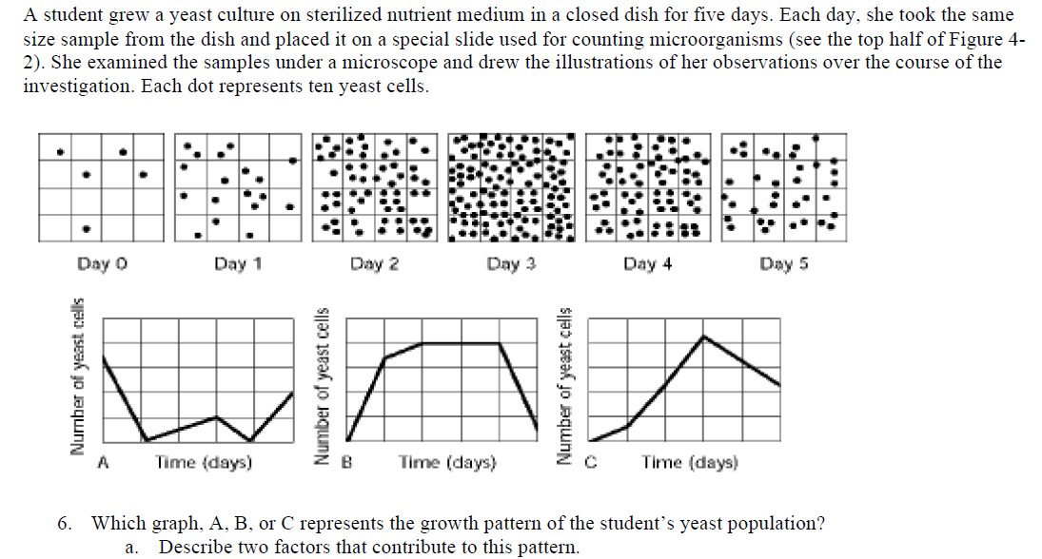
11

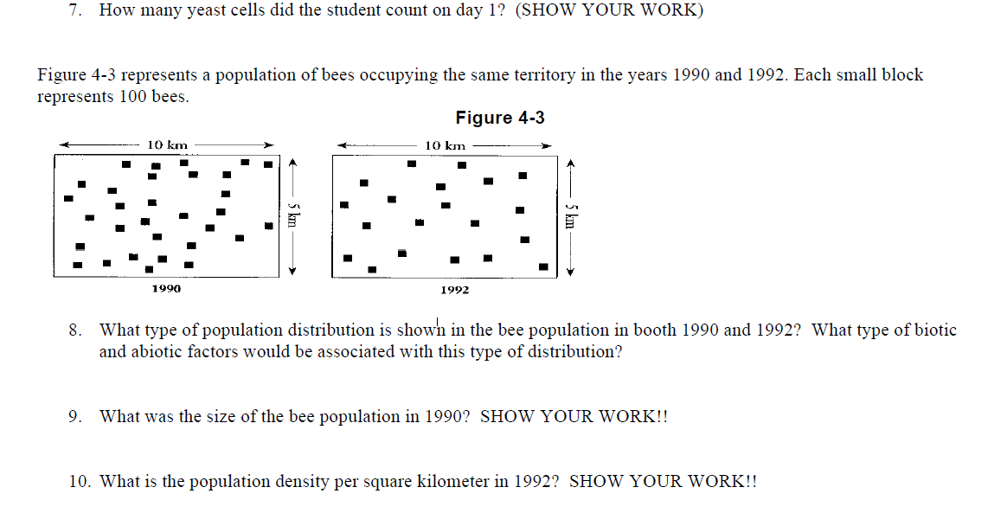
15
14
13
12

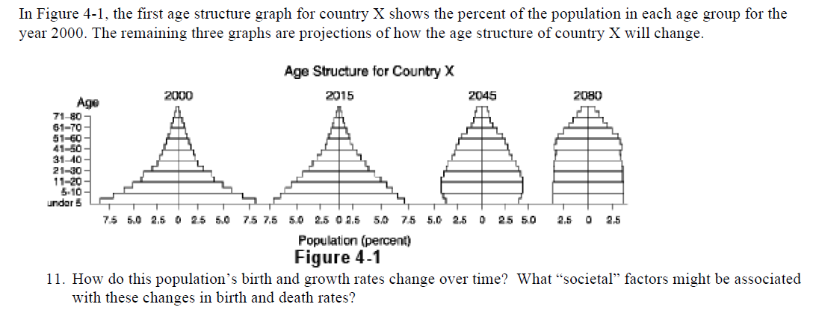
16
17
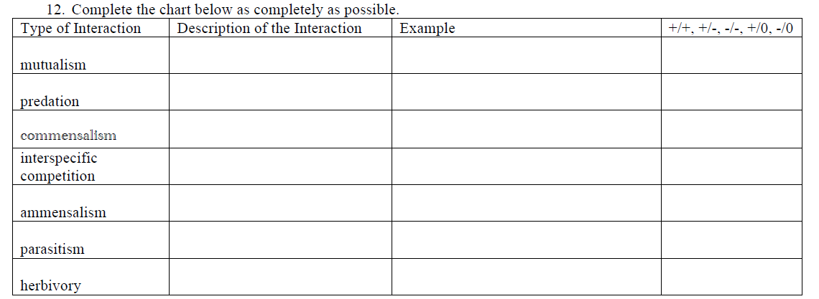

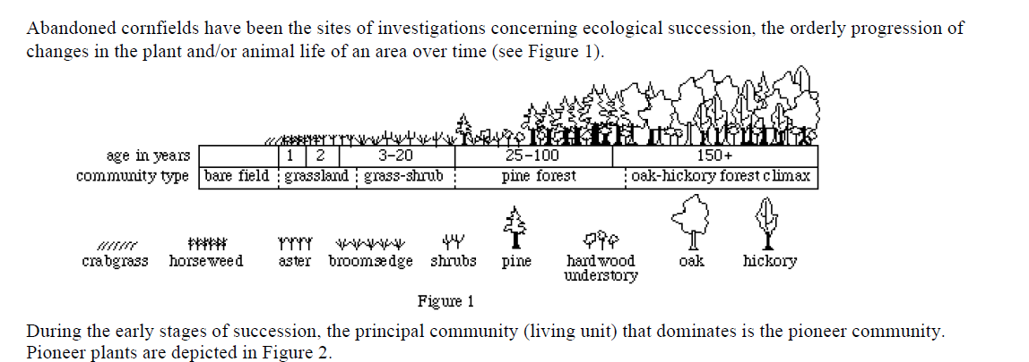

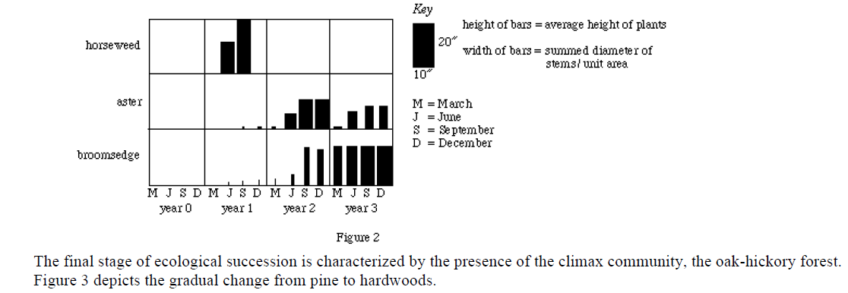

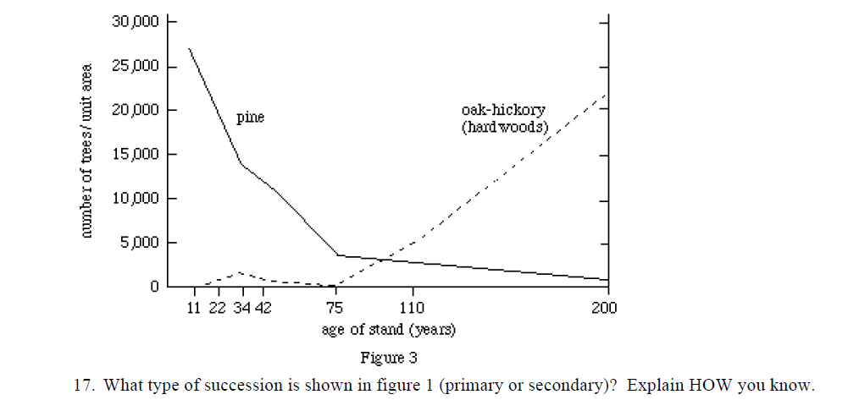
18

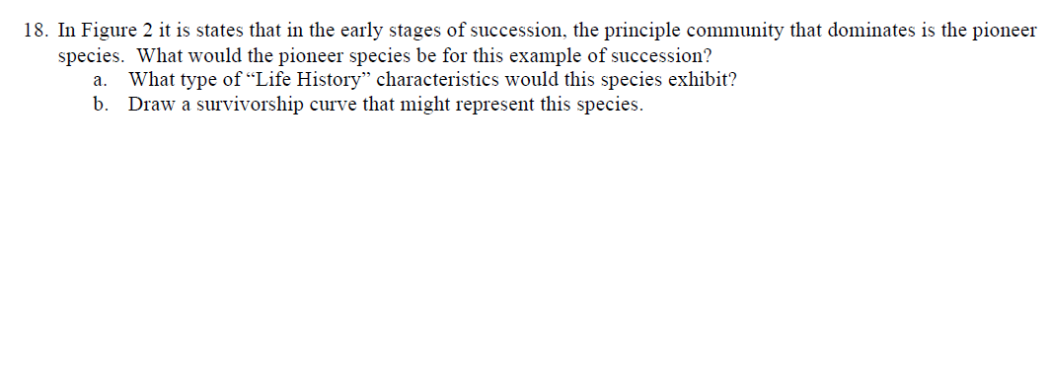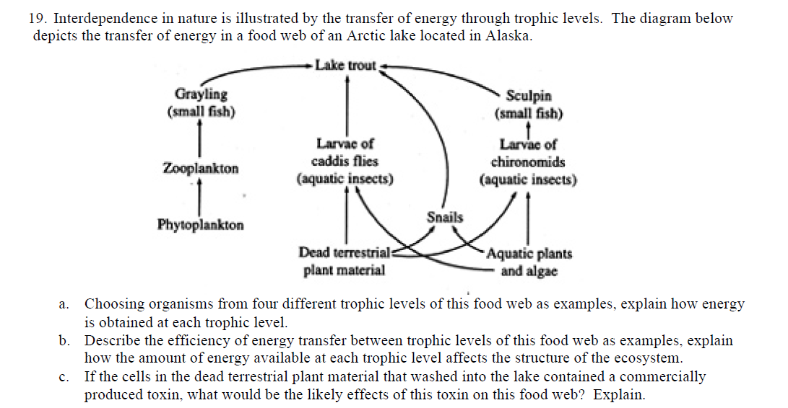
20
19

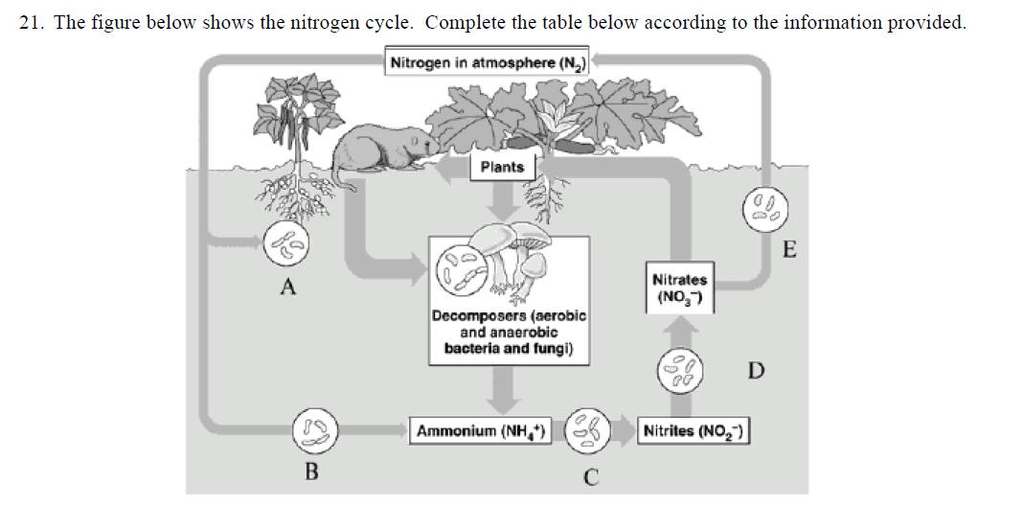

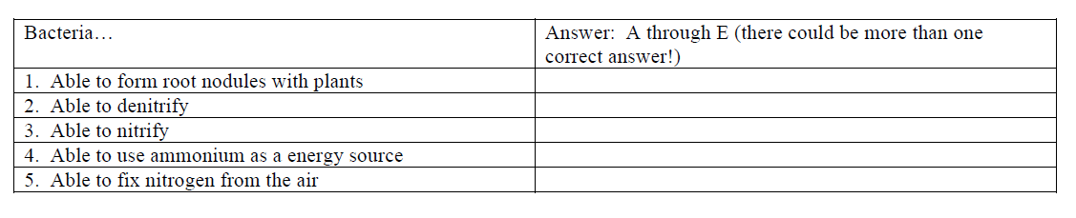

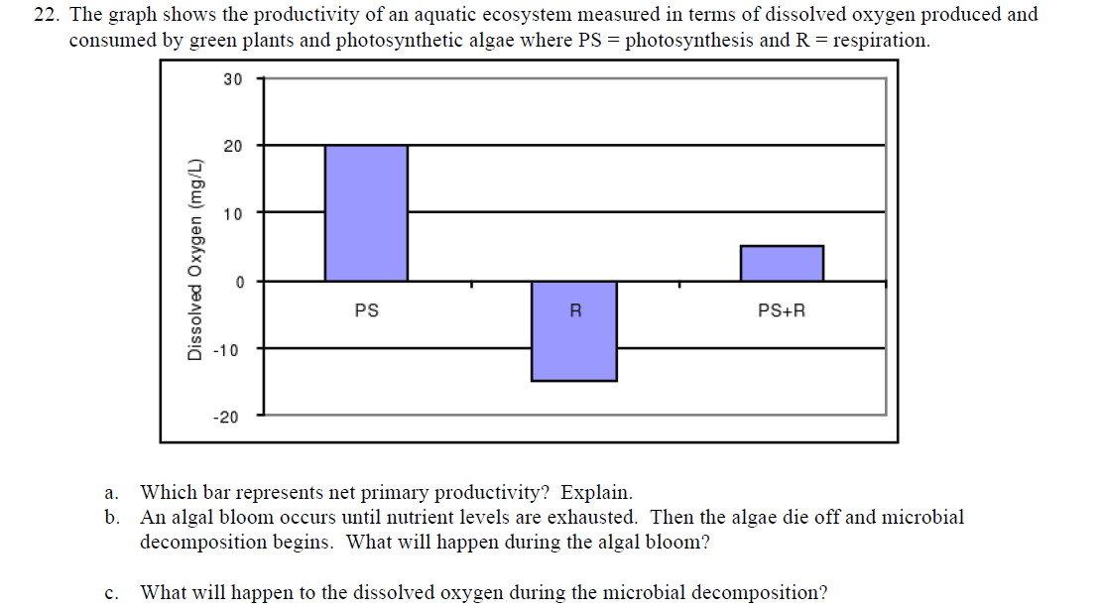

- Look at the data table below and calculate the growth rates for the California Quail for each year. The total population is 1000 individuals at the beginning of the year.
Quails | Births | Immigration | Deaths | Emigration | Population Size
Year 1 | 40 | 2 | 40 | 1
Year 2 | 46 | 5 | 45 | 0
Year 3 | 55 | 7 | 49 | 1
Year 4 | 68 | 2 | 55 | 4

- California quails will double its population size in how many years with the present growth rate of 1.5%?

- Use the following information to answer the following questions:
Population size= 500
Births= 240
Deaths= 170
a) How many individual will be in the population in the next generation (second) if there are no limiting factors?
b) How many individuals will be in the population in the next generation (third) if there are no limiting factors?
c) How many individuals would be in the population in the second generation if resources are limited and carrying capacity was 1000?
d) How many individuals would be in the population in the third generation if resources are limited and carrying capacity was 1000?

