EXAM PRACTICE - Evolution
AP Biology

1. As MC:

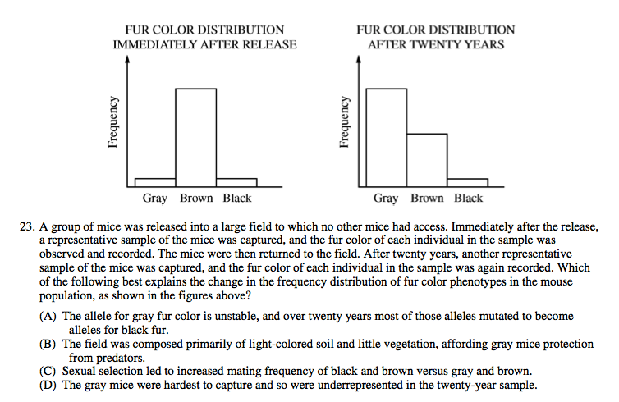

2. AS FRQ:

- Assume that in each study the combined frequency of phenotypes = 1.0. Given that, the Y axes intervals are not the same on the two graphs. Estimate the frequency of each phenotype in each population.

- Make multiple claims from the data in the graphs.

- Name and describe the type of selection occurring in the population

- Does the data support micro- or macroevolution in this population? Justify your choice.

3. AS GRID-IN:

A flock of 342 scarlet ibis includes 102 individuals
with green colored legs, the result of a mutation
Green is the dominant allele. Determine the frequency
of the green allele.

How many of the ibis are likely homozygous
for this trait?

4. Another MC

Water in a pond contaminated with the weed killer atrazine is suspected of inhibiting metamorphosis in northern leopard frogs. A team of scientists collected fertilized northern leopard frog eggs from a different pond that is not contaminated. Which of the following is the best experimental design to determine whether atrazine is responsible for inhibiting metamorphosis in northern leopard frogs?

(A) Place half of the fertilized eggs in a pool of water with the same concentration of atrazine as the contaminated pond and place the other half of the fertilized eggs in a pool of water that has no atrazine. Monitor the development of the embryos through metamorphosis into adulthood.

(B) Place all of the fertilized eggs in a pool of pond water with the same concentration of atrazine as the contaminated pond and compare the number of frogs that reach metamorphosis to those that reach adulthood in the contaminated pond.

(C) Allow all fertilized eggs to develop into adults. Expose one-third of the frogs to one-half of the concentration of atrazine in the contaminated pond and expose another one-third of the frogs to the same concentration of atrazine as the contaminated pond. Leave the last one-third of the frogs in water with no atrazine and note any adverse changes in the physical condition of the atrazine-treated frogs in three months.

(D) Divide the fertilized eggs into three groups and expose each group to a different concentration of atrazine. Release the eggs back into the contaminated pond and check
for metamorphosis after three months.

Key:

MC: A

FRQ: A. 0.1 : 0.8 : 0.1 fur color distribution initially 0.6 : 0.35 : 0.05 after 20 years

B. Gray increased in freq 500%
Brown decreased in frequency 56%
Black decreased 50%
Selection favors grey
Grey is most fit in new environment

C. directional – one extreme is selected

D. Micro – still one interbreeding population, just a frequency shift

