HW: FRQ Practice
AP Biology

1. You are stranded in the Arctic Ocean in a lifeboat with several others. You have run out of drinking water and are very thirsty. Others have started to drink sea water; before doing so yourself, you calculate the water potential of the relevant solutions to decide if this will speed up or slow down your dehydration.

- The majority of dissolved ions in seawater is NaCl. The ocean is 3.5% salt, a concentration of about 0.5M. Water temperature in the artic is 2C. Calculate the solute and water potential of the ocean.

- Your own cells have a 0.15M concentration of NaCl, and your body temperature is maintained at 37C. Calculate the solute and water potential of your cells.

- Use your calculations to describe the effect of a seawater environment on your cells. Determine the net direction of osmosis and net direction of the diffusion of salt.

- The lack of water also results in decreased blood volume. Low blood volume is detected by baroreceptors of the aorta and carotid arteries and the information is sent to the cardiac muscle of the heart. Predict the hearts response to this signal in order to bring blood pressure back up.

- The hypothalamus of a dehydrated person releases antidiuretic hormone (ADH) which signals the kidneys to recover water from urine, effectively diluting the blood plasma. To further conserve water, the hypothalamus also sends signals to the salivary glands in the mouth. Describe the effect of this signal on the mouth, the saliva consistency, and the saliva volume output.
2. Estrogens are small hydrophobic lipid hormones that promote cell division and the development of reproductive structures in mammals. Estrogens passively diffuse across the plasma membrane and bind to their receptor proteins in the cytoplasm of target cells.
- Describe characteristics of the plasma membrane that allows estrogens to passively cross the membrane.

- In a laboratory experiment, a researcher generates antibodies that bind to purified estrogen receptors extracted from cells. The researcher uses the antibodies in an attempt to treat estrogen-dependent cancers but finds that the treatment is ineffective. Explain the ineffectiveness of the antibodies for treating estrogen-dependent cancers.

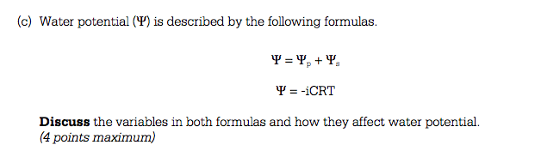
3.

4. A laboratory assistant prepared solutions of 0.8 M, 0.6 M, 0.4 M, and 0.2 M cellulose,
but forgot to label them. After realizing the error, the assistant randomly labeled the
flasks containing these four unknown solutions as flask A, flask B, flask C, and flask D.

Design an experiment, based on the principles of diffusion and osmosis, that the
assistant could use to determine which of the flasks contains each of the four solutions.

Include :

- a description of how you would set up and perform the experiment

- the results you would expect from your experiment

(c) an explanation of those results based on the principles involved

