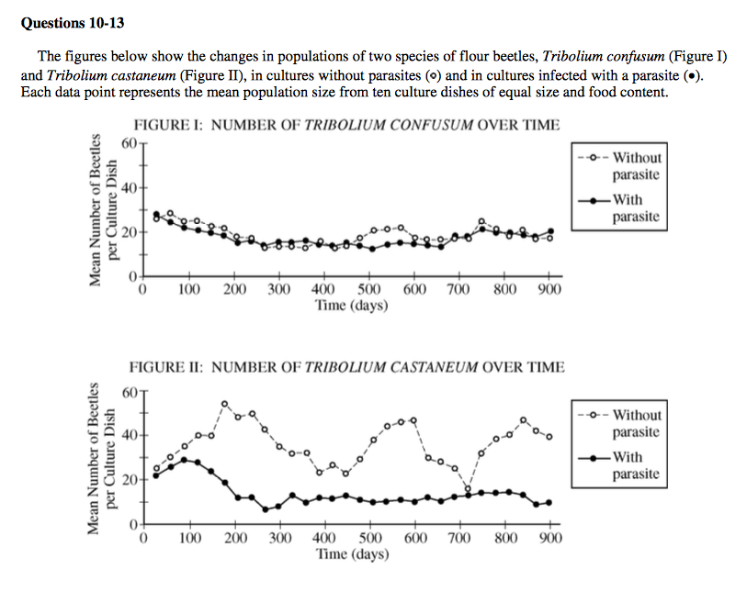
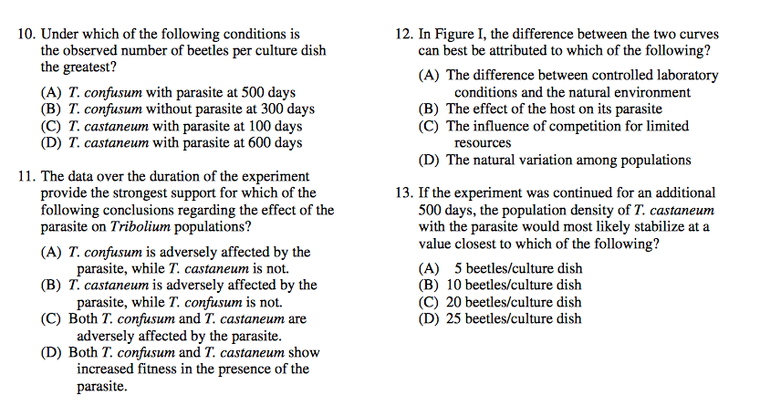
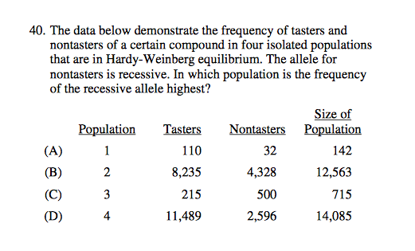
Questions 23 & 24:
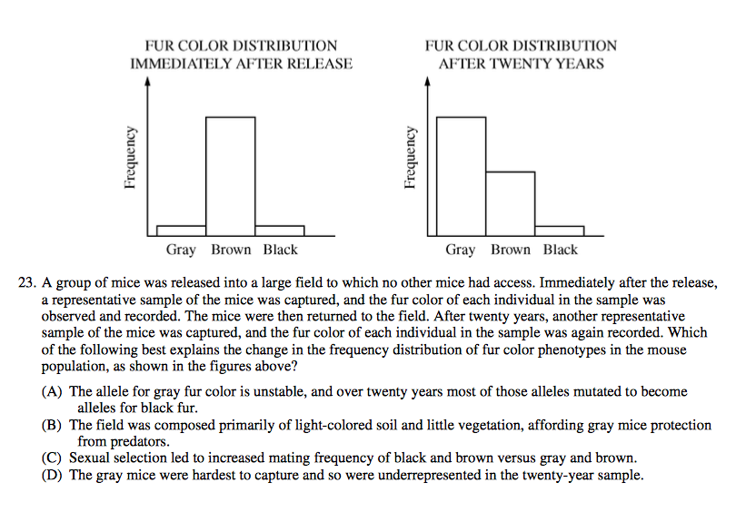
24. (FRQ)

- Make multiple claims from the graphed data

- Name and describe the type of selection occurring in this population.

- Does the data support micro- or macroevolution? Justify your choice.

