Practice FRQ: : Transformation lab
AP Biology

A scientist is using an ampicillin-sensitive strain of bacteria that cannot use lactose because it has a nonfunctional gene in the lac operon. She has two plasmids. One contains a functional copy of the affected gene of the lac operon, and the other contains the gene for ampicillin resistance. Using restriction enzymes and DNA ligase, she forms a recombinant plasmid containing both genes. She then adds a high concentration of the plasmid to a tube of the bacteria in a medium for bacterial growth that contains glucose as the only energy source. This tube (+) and a control tube (-) with similar bacteria but no plasmid are both incubated under the appropriate conditions for growth and plasmid uptake. The scientist then spreads a sample of each bacterial culture (+ and -) on each of the three types of plates indicated below.

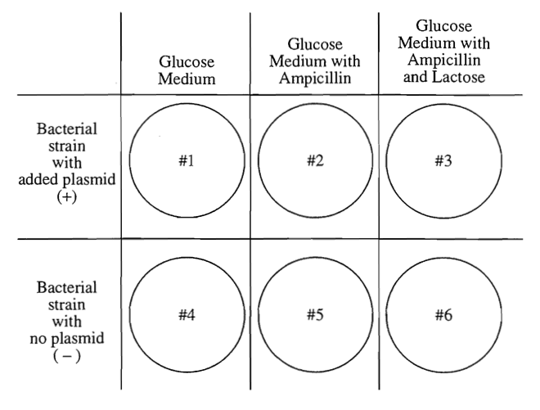

If no new mutations occur, it would be most reasonable to expect bacterial growth on any of the plates above? Specify and justify.

Explain the role of both the restriction enzymes and the ligase in the experiment protocol.

What is the purpose of the (-) trials?

