S.O.A.P.S. document analysis

1. Mark up/annotate the text Number the paragraphs, circle and find synonyms for unfamiliar words, underline sources, and take notes, using one of these three approaches:
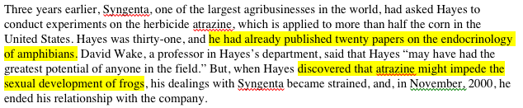
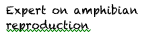
• Marginalia
highlight text evidence,
paraphrase claim in adjacent margin

• Claim (evidence) statement list

S: • Tyrone Hayes (handout citation)
• Expert on amphibian reproduction (P2 “twenty papers on the endocrinology of amphibians”)

• T table:

 | Claim | Evidence
S | Tyrone Hayes  Expert on amphibian reproduction | from handout citation  P2 “he had already published twenty papers on the endocrinology of amphibians”

2. Use S.O.A.P.S. to focus your reading: make claims about each of the topics and cite the evidence that supports your claim.

Speaker - Who is the author and what is their background? Are they knowledgeable and credible? Do they take a position, or have a bias?

Occasion - What is the time and place of the piece? What is the context that prompted the writing and publication of this text?

Audience - Who is the intended audience? (age, class, education, race…) What assumptions can you make about the audience? Why is the text directed at this audience?

Purpose - What is (are) the reason(s) behind the text? What is the author’s thesis? Is the address logical or emotional? In what ways does the author convey this? How is the document supposed to make you feel?

Subject - What is the subject of the document - the general topic, content, and ideas contained in the text?

3. Discuss, using your notes to articulate your opinions and interpretations of the text.

