S.O.A.P.S. document analysis

1. Mark up/annotate a text by numbering the paragraphs, circling and finding synonyms for unfamiliar words, and underlining sources.

2. Use S.O.A.P.S. to focus your reading: make claims about each of the topics and cite the evidence that supports your claim.

Speaker - Who is the author and what is their background? Are they knowledgeable and credible? Do they take a position, or have a bias?

Occasion - What is the time and place of the piece? What is the context that prompted the writing and publication of this text?

Audience - Who is the intended audience? (age, class, education, race…) What assumptions can you make about the audience? Why is the text directed at this audience?

Purpose - What is (are) the reason(s) behind the text? What is the author’s thesis? Is the address logical or emotional? In what ways does the author convey this? How is the document supposed to make you feel?

Subject - What is the subject of the document - the general topic, content, and ideas contained in the text?

3. In discussion, use your notes to articulate your opinions and interpretations of the text.

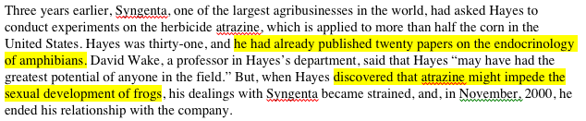
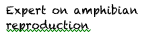
4. Notes options

• As ‘marginalia’:
highlight text evidence,
paraphrase claim in adjacent margin

• As bulleted list of claim (evidence) statements, by SOAPS letter:

S: • Tyrone Hayes (handout citation)
• Berkeley professor of Biology since 1994 (P1 “In 2001, seven years after joining the biology faculty of the University of California, Berkeley,”)
• Expert on amphibian reproduction (P2 “published twenty papers on the endocrinology of amphibians”)

• as a T table:

 | Claim | Evidence
S | Tyrone Hayes  Berkeley professor of Biology since 1994  Expert on amphibian reproduction | from handout citation  P1 “In 2001, seven years after joining the biology faculty of the University of California, Berkeley,”  P2 “he had already published twenty papers on the endocrinology of amphibians”

